RTI
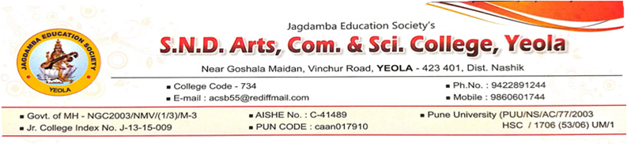
DECLARATION UNDER RIGHT TO INFORMATION (RTI)
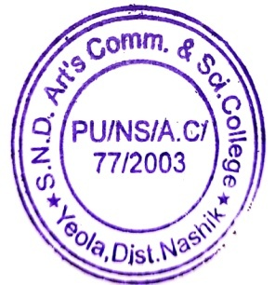
STATUTORY DECLARATION ON RTI ACT section 4(1) (b) of RTI Act 2005 covers the statutory declaration of Jagdamba Education Society’s S.N.D. Arts Commerce and Science College, Yeola website . It covers all rules and regulation which are implemented by Govt. of Maharashtra. Our college is “College of Co-Education “, which is affiliated to Savitribai Phule Pune University, Pune, and Maharashtra. It runs as per rules and regulation made by the Govt. time to time .The college comes under Non-Grant and under self-finance category. Financial transaction are audited by authorized auditor. The college has different bodies to maintain all types of disciplines in campus. The application under the RTI Act along with a postal order / Demand Draft for Rs.10.00 obtained in favors of principal, S.N.D. Arts Commerce and Science College, Yeola, may be sent to the Public Information Officer (PIO) or handed over in his office. All information about the college under section 4 (1)(b) of RTI Act.2005 are open for public and it can be obtained by a citizen of India .
